**The Amsterdam Hackathon – 29 June 2013**

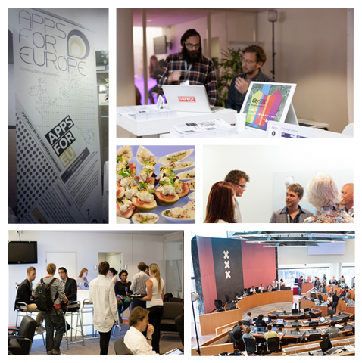

The Amsterdam Hackathon gathered 17 teams of young IT professionals representing 4 European countries Netherlands, UK, Finland, and Austria. The majority of projects were dedicated to transport, education and culture. Based on the Business Lounge criteria (Technology, Innovation&Business, Market and Organisation) the final ranking was as follows:

1. [i-Kringloop](http://www.ikringloop.com/) Winner! i-Kringlooop is therefore one of our Apps for Europe [Case Studies](http://www.appsforeurope.eu/case-studies) and the makers have been invited to exhibit at our International Business Lounge at[Future Everything](http://futureeverything.org/ongoing-projects/apps-for-europe/) in Manchester March 31st 2014.  
  
2. [Digiloket](http://www.scholenkeuze.nl/)  
**The concept:**An online tool to inform citzens about all educational establishments throughout the Netherlands, from elementary schools to Universities.   
**Business Aspect:**We already have customers (municipalities) who pay to incorporate our tool into their community so they can 'talk' to their citizens online.   
**Looking for:**Partnership with other relevant parties to enable growth of staff - particularly technical, sales and social media assistance. Funding for marketing and research activities.

3. [Push2Press](http://itunes.apple.com/us/app/push2press/id603889484?mt=8)  
**The concept:**An open source Native App CMS that accelerates the development of iPhone and Android apps that have built-in Push Notification functionality.   
**Business Aspect:**The long term plan is to generate more sustainable and significant income by providing more value added services to support the platform and its use. Word Press is our inspiration. We have a viable product and service offering to extend beyond Amsterdam and the Netherlands.   
**Looking for:**Strategic partnerships with multinationals that have existing global channels to market and would like to contribute to the growth of the Push2Press Open Source Platform.

4. [Muse](http://www.muse-opensource.org/). Open Source Platform  
**The concept:**A software platform that enables the publication of Apps.  
**Business Aspect:**We have already generated revenue through app sales to the customer market (Rijksmuseum Muse).   
**Looking for:**Collaborative business models- potentially profitable revenue sharing. Strategic partnerships with multinationals that have existing global channels to market and would like to contribute to the growth of Muse Open Source Platform.

5. [City Navigator](http://dev.hsl.fi/fe2013/)  
**The concept:**Like a car GPS navigator but for public transport passengers: a navigation application for on-the-go use, to take away the unpredictability of public transport.   
**Business Plan:**The app is straightforward to deploy in new cities. Our main business idea is to make products out of the technologies embodied in our app for businesses and authorities who would benefit from them to include the features in their offerings.   
**Looking for:**  Mentoring to help build a feasible business model to launch the product internationally. Support with market research.  
  
To browse more entries click on the links below:

[OmgevingsAlert](https://itunes.apple.com/nl/app/omgevingsalert/id491137655)

[Spotzi-Local](http://www.spotzi.nl/)

[Lawcat](http://lawc.at/)

[Openbaar Vervoer](http://openbaarvervoerapp.nl/en.html)

[Open Huis App](http://itunes.apple.com/nl/app/open-huis-alles-over-wonen/id606992210?mt=8)

[HoogeNood](http://www.hogenood.nl/)

[PAC-Manchester](http://foxdogstudios.com/pac-manchester.html)

[Go Board](http://iodatalabs.com/appsforeurope/goboard)

If these sound good to you and you want to see all projects entered into The Amsterdam Hackathon, you can! Here is the [full information pack](http://www.appsforeurope.eu/file/130).